Stats Video Lectures – Robust Statistics

Week 1, Video 9

1. Define Robust Statistics
   1. the measures on which extreme observations have little effect
   2. Robust statistics are good for skewed data sets with extreme observations
   3. Non-robust statistics are good for measuring symmetrical data with few extreme observations
2. medians are robust to extreme observations compared to the mean  
   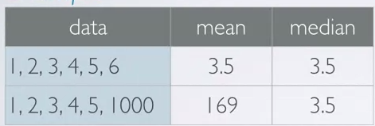
3. IQR is based on the median, thus is more robust than the standard deviation and the range